To be returned to:-

NORTH/EAST: Clare Woodman (clarewoodman@warwickshire.gov.uk)

CENTRE/SOUTH: Sandra Bowering (sandrabowering@warwickshire.gov.uk)

CHILDMINDERS: Harjinder Bahra (harjbahra@warwickshire.gov.uk)

CLOSING DATE FOR APPLICATIONS: 25th March 2019
Setting Name:

Setting type: PVI/LA/Childminder
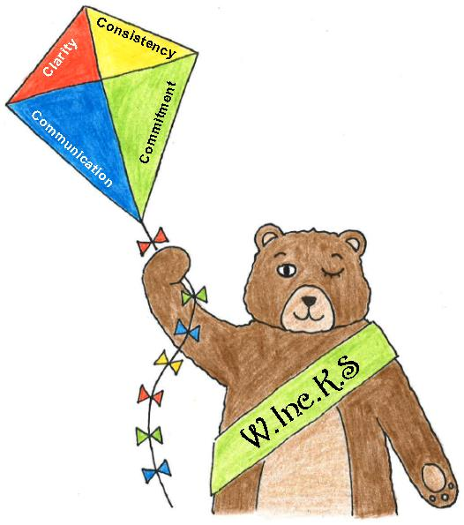
Name of Setting/Childminder:

Name of SENDCo:

Address:

Contact number:
Email:
Date:

Name of IDS professional recently contacted (if known):
SEND Education Provision Matrix (Pre-School)
UNIVERSAL PROVISION (please complete as fully as possible, with examples)
Warwickshire Pre-School Settings will offer to all learners:

U | UNIVERSAL PROVISION | Tick if in place () | Please give examples (with dates where appropriate):- | Indicate any actions that you are planning to work on in the coming year: | Please leave blank for IDS evidence ()
Universal Provision consistent strategies used by all. | Systems
Universal Provision consistent strategies used by all. | The SENDCo will:  Be identified and known to all staff and families.
Universal Provision consistent strategies used by all. | Have an identifiable SEND “file” (previously known as the “green file”) containing all relevant and up-to-date SEND information.
Universal Provision consistent strategies used by all. | Have contact information for the IDS Specialist Pre-School team.
Universal Provision consistent strategies used by all. | Know how to complete a SPA form and refer to the IDS Pre-School team.
Universal Provision consistent strategies used by all. | Have SENDIAS details (previously Parent Partnership) to give to families.
Universal Provision consistent strategies used by all. | Have access to guidelines for managing personal care (toileting) and Health Care needs where appropriate (eg. a health care plan, written with a health professional).
Universal Provision consistent strategies used by all. | Have a SEND Policy in place.
Universal Provision consistent strategies used by all. | Have a Policy for developing Positive Behaviour.
Universal Provision consistent strategies used by all. | Have an awareness of the “Local Offer” for Warwickshire SEND  http://www.warwickshire.gov.uk/send  and can show others how to access the information.
Universal Provision consistent strategies used by all. | Use Risk Assessments as appropriate.
Universal Provision consistent strategies used by all. | Access specialist support, advice and/or intervention from IDS Teaching and Learning (Give details).
Universal Provision consistent strategies used by all. | Attend IDS SENDCO surgeries/training  (Give details).
Universal Provision consistent strategies used by all. | Inclusive Partnership with Families
Universal Provision consistent strategies used by all. | All staff consistently demonstrating:-  - An inclusive ethos and commitment  - Regular two-way communication with families  - Opportunities to work together and share good practice  - Evidence of including children in their own decisions, preferences and choice-making
Universal Provision consistent strategies used by all. | Teaching & Learning
Universal Provision consistent strategies used by all. | All staff consistently using recommended interventions and resources in relation to:  - EYFS  - SALT programmes; Wellcom Tool (Time to Talk), etc.  - Positive Behaviour Management  - Teaching Talking Profile  For Individual children, there will be:  - Clearly identified outcomes in place using SMART targets  - Targeted observations, with evidence of actions from the collated information  - Regular discussions with parents to share ideas successes, concerns and next steps  - Involvement with the child’s Health Visitor  - Referrals to SALT / other Health professionals as appropriate  - Risk Assessments & Care Plans, as appropriate
Universal Provision consistent strategies used by all. | Referral to /Liaison with other agencies, as appropriate
Universal Provision consistent strategies used by all. | Physical Environment
Universal Provision consistent strategies used by all. | An environment where all methods of communication are used to support all children to understand and communicate:  - Symbols used, eg. Communicate In Print  - A visual timetable and other visual support  - Makaton/Gestures used consistently  - Appropriately sized furniture/chairs/toilets  - Resources clearly labelled  - Good use of signs, symbols, photographs, gestures, all used to support teaching & learning – please give examples
 | Staffing & Professional Development
- Staff used flexibly to provide small group and 1-1 input. (Frequency)?
- Staff use simple language when giving instructions.
- Individual/ groups of staff attend relevant training SEND training – give examples
- Evidence of Whole-Staff training around SEND and inclusion (this could be in-house, staff meetings, commissioned training, etc.) – give examples

Outcomes: Please leave blank for IDS to complete (comments and examples)

NOW PLEASE PROVIDE EVIDENCE OF WHAT YOU PROVIDE AT A “TARGETED” LEVEL
(we often refer to this provision as “additional to” or “different from”)

“TARGETED” PROVISION: Please read the following, before providing your own examples.

Have you evidenced all consistent elements of “universal” SEND provision, including aspects that you may be working towards as part of whole-staff professional development? If so, please continue:-

At the kite-marking workshops across the county, practitioners were asked to consider 4 themes that had been highlighted during extensive inclusion research; Communication, Commitment, Clarity and Consistency. We also discussed some of the emerging principles raised by families and pre-school settings. These might help you:-
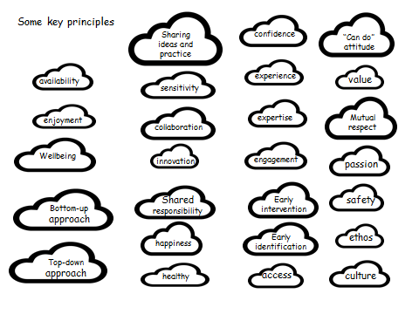
“TARGETED” PROVISION: Please give illustrations in your setting
- What “targeted” provision can effectively be offered for children with SEND (that is "additional to" or "different from")?

- How do you communicate and work in partnership with families when their children have SEND?

- Are you able to clearly describe how your inclusive ethos and commitment is demonstrated – not only in your written policies, but practically and on a daily basis?

(PLEASE AVOID USING PHOTOGRAPHS OF CHILDREN IN YOUR APPLICATION)
Thank you and Good Luck!

