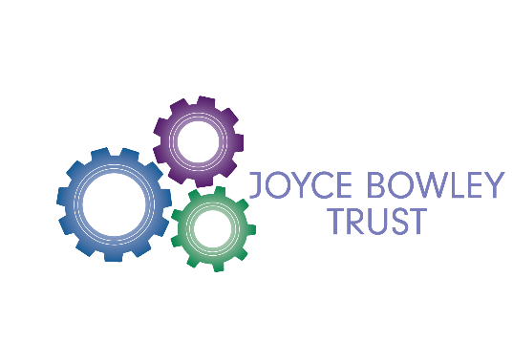

**The Joyce Bowley Trust in Partnership with Hillmorton Teaching School Alliance**

The Joyce Bowley Trust, in partnership with Hillmorton Teaching School Alliance is committed to improving the life chances of children across the Rugby area. We collaborate to provide fully-funded or subsidised training to adults working in school to support children with social and emotional needs.

**About the Joyce Bowley Trust**

Joyce Bowley was the Rugby Area Manager for the Learning and Behaviour Support Service, Early Intervention and then Specialist Teaching Service from 1996 until 2017. Joyce was well known to, and highly respected by Head Teachers, SENCOs, teachers and support staff working to ensure children with SEND were able to thrive in Rugby Schools. Joyce was a keen trainer, mentor and coach to many in the area and sought to foster joint working and sharing best practice. The Joyce Bowley Trust established in her memory by family and friends, seeks to continue her work through supporting projects that builds staff confidence that they can meet the needs of children with social and emotional needs. The Trust hopes that over the years we can provide some additional resource to add to the good practice already in place in Rugby primary phase schools. We are delighted to be doing this in partnership with the Hillmorton Teaching School Alliance.

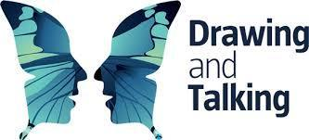**Current Projects**

**Drawing and Talking**

Drawing and Talking is non-invasive intervention where children can be given the opportunity to work through their concerns without having to admit to them. The process takes 12 weeks, with a new picture each week. The trained practitioner will ask pertinent questions to encourage conversation. The intention is for the child (and practitioner) to absorb themselves into the picture, allowing the right and left hemispheres of the brain to process the concerns in a logical manner.

The Joyce Bowley Trust fully subsidised 6 Rugby Primary schools to attend the foundation stage of training, to become practitioners in the therapy. The trained practitioners meet regularly as part of a special 'Drawing and Talking' network.

More information on Drawing and Talking can be found by visiting: <https://drawingandtalking.com/>

**Thrive**

Thrive® promotes children’s and young people’s positive mental health by helping adults know how to be and what to do in response to their differing and sometimes distressed behaviour.

Based on established neuroscience, attachment theory and child development, the Thrive Approach provides training and an online profiling and action-planning tool to equip adults with the knowledge, insights and resources needed to develop the relationships that help children and young people to flourish and learn.

Funding provided by the Joyce Bowley Trust alongside a Warwickshire School Improvement Bid has subsidised the training of twelve ‘Thrive Licensed Practitioners’ in Rugby and the surrounding areas who will form a special Rugby 'Thrive Network'.

More information on the ‘Thrive Approach’ can be found by visiting: <https://www.thriveapproach.com/>