Dear parents

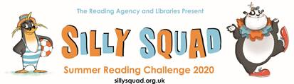

Illustrations © Laura Ellen Anderson 2020

I am delighted to confirm that Warwickshire Libraries will be running the annual national Summer Reading Challenge for primary-school aged children this summer. The theme is fun books and a great tonic in these difficult times. Here is some information from the national organisers, The Reading Agency:

‘There are a number of high profile children’s authors who are helping to promote the Challenge this year - Jacqueline Wilson, Paul O'Grady, Cressida Cowell (Children’s Laureate), Charlie Condou, Philip Ardagh, David Baddiel, Rob Biddulph, Sam and Mark, Hacker T Dog, Ben Fogle, Joseph Coelho, Katie Thistleton, Harry Baker and Konnie Huq.

The much-loved Jacqueline Wilson has written:

“I feel the Summer Reading Challenge is extra important this year! How sensible to have a Silly theme. We've all had to deal with serious and scary issues, so it's time for a bit of fun. There are so many comical and crazy children's books to cheer us all up. Let's get reading and get happy!” - **Jacqueline Wilson**, Summer Reading Challenge Ambassador

The launch on 5th June featured special super silly readings, family activities and draw-a-longs from guest celebrities and authors. These should still be available to download from the national site if you missed them.

Over the summer, libraries will continue to run the Challenge in partnership with The Reading Agency, delivering it via virtual services and e-lending platforms, and adapting their delivery if social distancing measures develop and change.’

Whereas children would normally have gone to their local library to sign up, with parental permission, this year children need to be registered on the national Challenge site, and parents / guardians need to do this for them. This is to ensure security of the data and allow statistical information to be passed back to each local authority as the Challenge progresses.

The national ‘Silly Squad’ website is here: **www.sillysquad.org.uk**

In Warwickshire there will be additional activities online on the public libraries website:

**https://www.warwickshire.gov.uk/libraries**

You can also access e-books and audiobooks to read, free of charge from the site. If you are not a member of the library service it is easy to sign up online for a card here:

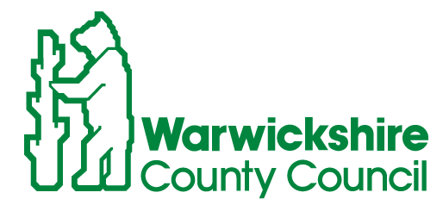**https://www.warwickshire.gov.uk/jointhelibrary**