

29th January 2021

**Re: Launching Coventry and Warwickshire’s Keyworker pilot project**

Dear Colleague,

We are pleased to announce the launch of the key worker pilot and the new keyworker roles to support children and young people with autism and/or learning disabilities across Coventry and Warwickshire aged 14-25 years. The roles commence from 25th January 2021 and will be hosted by Coventry and Warwickshire Mind on behalf of Arden’s Transforming Care Partnership.

Our aim is to deliver flexible, personalised and child-centred support, to ensure the complex and often varying needs of children, young people and their families are met. The key worker role will work with children, young people, their families and clinical teams to ensure we all work together to get the best outcome for them.

The Keyworker function is an important response to the NHS Long Term Plan (LTP) which has a commitment that by 2023/24, children and young people with a learning disability, autism or both, with the most complex needs will have a designated Keyworker.

Key workers will be facilitators for children, young people and their families/carers and part of a wider package of care. You can find more information about the new role and key functions in the attached job description along with a FAQ document.

Your role as a key stakeholder/service provider doesn’t change and we welcome your support in implementing this function across the system. Should you require any further information, please contact Maria Dainter, Team Leader Specialist Key Worker Pilot, maria.dainter@cwmind.org.uk.

Yours sincerely, 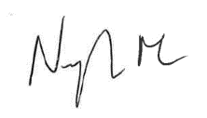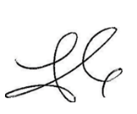   
  
John Gregg Jo Galloway Nigel Minns

Strategic Director - People   
Warwickshire County Council

Director of Children’s Services  
Coventry City Council

Chief Nursing Officer & Deputy Accountable Officer  
NHS Coventry and Rugby CCG