

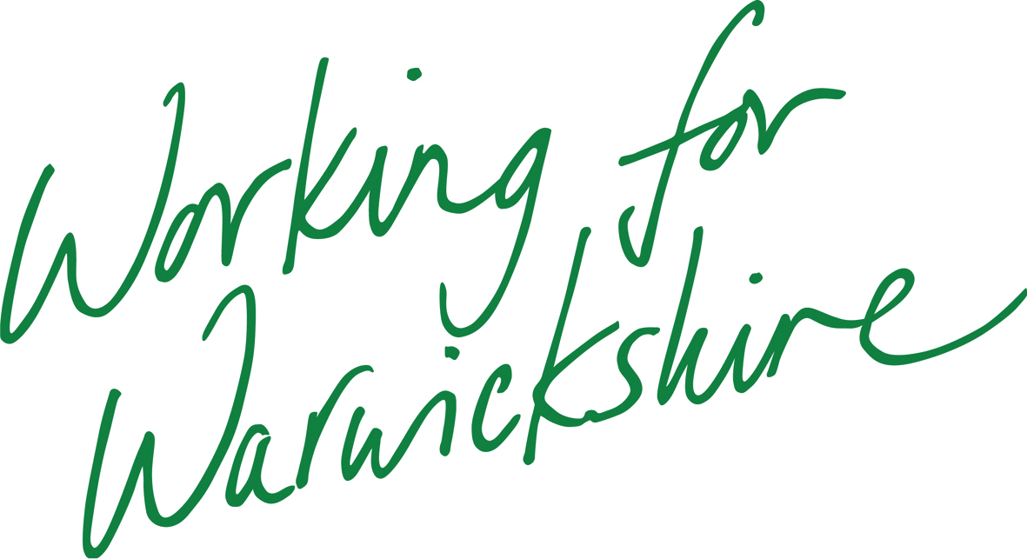

**School Governing Board Details:**

Please can you complete the form with your current Governing Board details and then return it to: amandagardiner@warwickshire.gov.uk

|  |  |  |  |  |
| --- | --- | --- | --- | --- |
| **Name of School:** | | | | |
| Type of Governor | **Number specified on the instrument** | **Current number in post** | **Current Vacancies** | **Additional comments** |
| Governors |  |  |  |  |
| Parent Governor |  |  |  |  |
| Local Authority Governor |  |  |  |  |
| Staff Governor |  |  |  |  |
| Head teacher |  |  |  |  |
| Co-opted Governor |  |  |  |  |
| Foundation Governor |  |  |  |  |
| Associate Member |  |  |  |  |
|  |  |  |  |  |
| **Form completed by:** | |  |  |  |
| **Date completed:** | |  |  |  |
|  |  |  |  |  |

|  |  |  |  |  |  |
| --- | --- | --- | --- | --- | --- |
| **Governor Information:** | | | | | |
| **Name of Governor** | **Type of Governor** | **Position on Governing Body** | **Telephone Contact Details** | **Email Address** | **Appointment Dates**  **From – to** |
|  |  | **Clerk** |  |  |  |
|  |  | **Chair** |  |  |  |
|  |  | **Vice Chair** |  |  |  |
|  |  |  |  |  |  |
|  |  |  |  |  |  |
|  |  |  |  |  |  |
|  |  |  |  |  |  |
|  |  |  |  |  |  |
|  |  |  |  |  |  |
|  |  |  |  |  |  |
|  |  |  |  |  |  |
|  |  |  |  |  |  |
|  |  |  |  |  |  |
|  |  |  |  |  |  |
|  |  |  |  |  |  |
|  |  |  |  |  |  |

