**REFUGEE WEEK**

**19 to 25 June**



During Refugee Week, there are numerous ways to demonstrate compassion, and volunteering for Care4Calais is one impactful avenue.

In April 2023, a group of 14 Warwickshire teachers embraced this opportunity, as detailed in their visit documented on the padlet link provided: <https://padlet.com/nikkiajibade/care4calais-warwickshire-neu-volunteers-i2ciinceyfxnaxly>.

Nicci Burton, Executive Head Teacher of Federation: Bedworth Heath Nursery School and Atherstone Nursery School, eloquently presented their experience at the NEU AGM on May 23rd, 2023.

To learn more about getting involved with Care4Calais, visit their website through the following link: <https://care4calais.org/>

Additionally, EMTAS offers funded Refugees in Warwickshire Schools training, and to secure a spot, reach out to Melinda Twells at [melindatwells@warwickshire.gov.uk](mailto:melindatwells@warwickshire.gov.uk).

As Albert Einstein once said, "Our task must be to free ourselves – by widening our circles of compassion to embrace all living creatures and the whole of nature in its beauty."

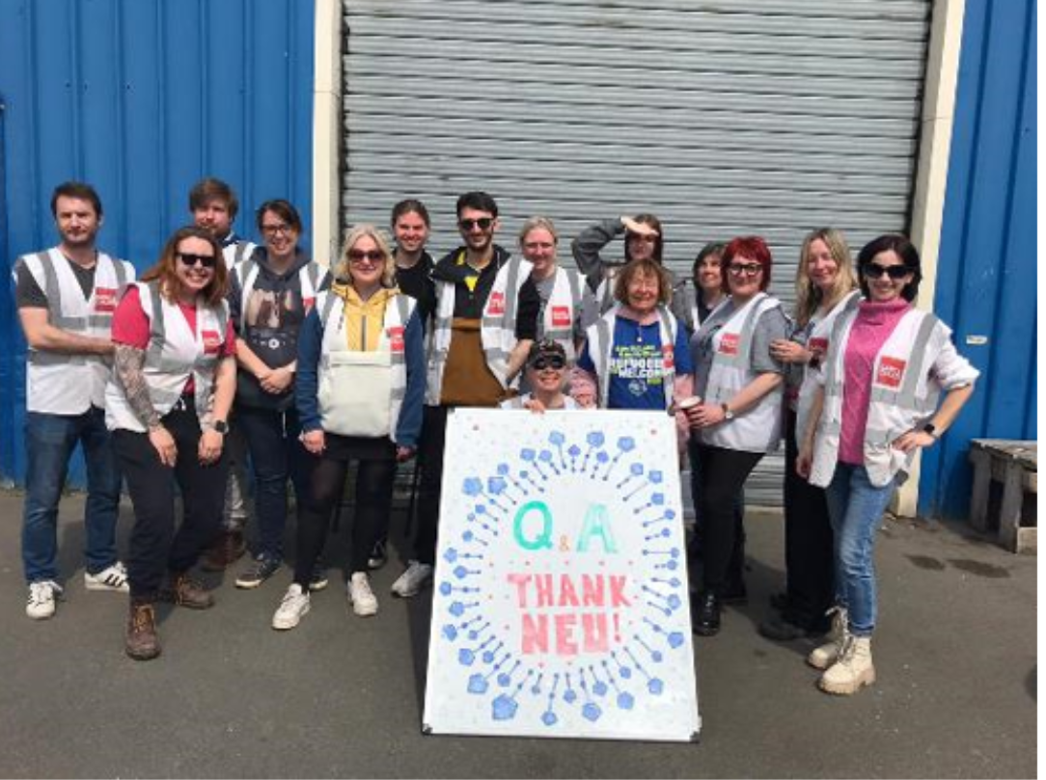

Submitted by: Nikki Ajibade, Joint Senior Lead

Ethnic Minority Traveller Achievement Service [EMTAS] in Education & Learning