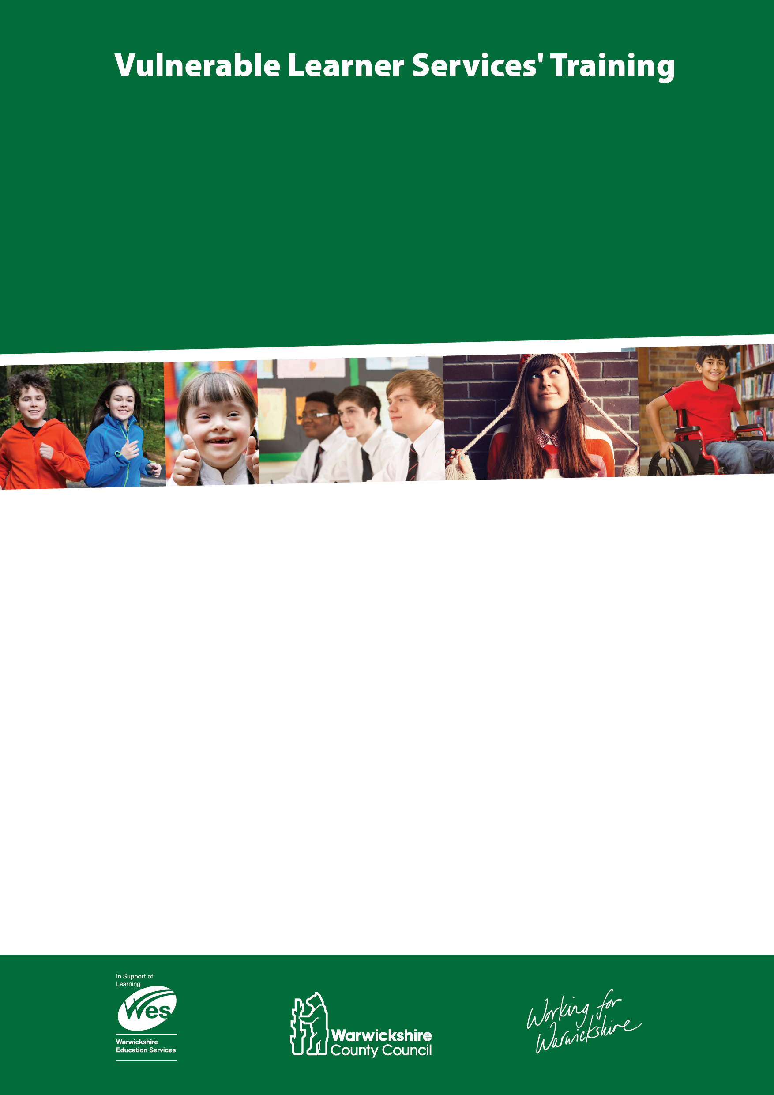

**SENCOs, Senior SEN Leads are invited to attend:**

* HMI – Morag Kophamel

“Evidencing impact for Learners with SEND”

* LA Update
* Speed dating

Taster sessions on Talk Boost, Language for Learning, Talking Partners, Inference Training and Communicate in Print.

* Exploring Maths Learning Difficulties

A brief overview exploring current research as to why some children struggle to acquire a basic understanding of number and the number system.

£50 per person, booking is essential to reserve your place press control & click [here](https://docs.google.com/a/warwickshire.gov.uk/forms/d/1ZZ9r9hX-XSEDRu7egzCvne1SIlnp5T_uZAV5I9StjmY/viewform)

to complete the booking form or any queries please email [meltwells@warwickshire.gov.uk](mailto:meltwells@warwickshire.gov.uk)

Places are limited to two per school

£50 per person, booking is essential to reserve your place press control & click [here](https://docs.google.com/a/warwickshire.gov.uk/forms/d/1ZZ9r9hX-XSEDRu7egzCvne1SIlnp5T_uZAV5I9StjmY/viewform) to complete the booking form or any queries please email meltwells@warwickshire.gov.uk

Places are limited to two per school

**Primary SENCO Conference**

Monday 10th October 2016

**Dunchurch Park Hotel**

Rugby Road, Dunchurch, Rugby, CV22 6QW

**8:45 – 4pm**