**SLCN in the early years**

**– module one**



**About I CAN**

**I CAN is the children’s communication charity. We are experts in helping children develop the speech, language and communication skills they need to thrive in a 21st century world. We are here to ensure that no child is left out or left behind because of a difficulty speaking or understanding. Our vision is a world where all children have the communication skills they need to fulfil their potential.**

Language is the fundamental life skill, essential for all learning, for making friends and for life. But nearly one and a half million children have severe communication difficulties, and in some areas over half of children start school with delayed language.  Often unidentified, and therefore with no support, children with communication difficulties will find life hard.

Communication difficulties are not visible, often mistaken for something else, or not noticed at all.

Speech, language and communication needs (SLCN) are life limiting. A child who struggles to speak or understand will find it hard to learn, manage school and make friends.

One in ten children has more severe difficulties and needs long term support. In some socially deprived parts of the UK, upwards of 50% of children are starting school with poor language skills and need targeted, shorter term support to develop age related expectations.

I CAN is working to make sure that everyone in contact with children knows how important communication is, what a communication difficulty looks like and what they can do to help.

We do this through:

* Supporting children and young people’s speech, language and communication needs (SLCN) to ensure they get the help they need.
* Bringing about change to the services available to children with SLCN
* Focusing on building strong partnerships and collaboration.

I CAN

31 Angel Gate,

Goswell Road,

London,

EC1V 2PT

Tel: 020 7843 2510

<https://www.ican.org.uk/>

Tel: 0845 225 4073

## Training for early years setting practitioners, managers and SENCos

## Learning outcomes

**By the end of this module, participants will:**

* have considered what speech, language and communication needs (SLCN) are, identifying some impact on early years
* develop an understanding of how to identify SLCN in the early years
* consider the cycle that will enable young children with SLCN to access to the curriculum
* agree three personal targets for implementation in the workplace.

**Note that all staff can identify their levels of knowledge by using the Speech, Language and Communication Framework self-review tool www.slcframework.org.uk/**

**Structure of training**

This training is delivered through two webcasts. This webcast is module one. The module is designed to take less than 90 minutes to work through.

There is information provided on screen, with activities for you to carry out on your own, or in small groups if you are accessing the webcast together.

Please pause the webcast when asked to do so, to allow time for reflection and for you to carry out your activities. If you are accessing the webcast in a small group, allow time to share your answers for each activity with each other. Additionally, you can pause, or review the webcast at any time.

After you have viewed this module (module one), choose a time when you will view module two. You can then take part in an on-line webinar which will enable you to ask any questions and discuss how you can implement what you have learnt into your early years setting. There will also be information on how you can gain your certificate. You can find more details of the webinar on <https://ican.org.uk/eysend-partnership/>.

### Learning log

### We have provided a learning log for you to make notes on as you go through the webcast. Use it to note actions, commitments and queries. You can refer to it later in your setting and in the follow-up webinar.

**Speech, language and communication**

|  |
| --- |
| **Activity one. Why is communication important?** |
| **Note down why you think communication is important, especially to children in the early years.** |

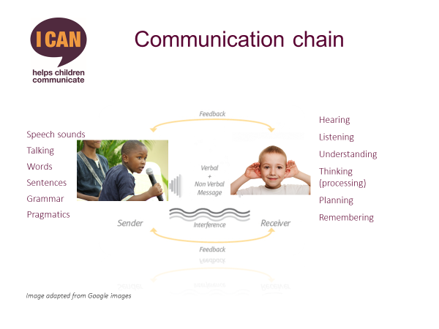

**Note:**

The communication chain can be broken down into:

* ‘speech’ - sounds and sound combinations put together to make words;
* ‘language’ - understanding words / sentences also known as ‘comprehension / receptive language’, and includes talking - also known as ‘expressive language’
* ‘communication’ – a way of sharing feelings and emotions; a tool for giving and receiving information.

These are different aspects of the interactive process. All are necessary for effective communication.

**Did you know?**

*At age 4–5 when children start primary school, they should have reasonably proficient speech, language and communication skills.*

*For example, 4 – 5 year old children with age appropriate speech, language and communication skills can:*

* *understand teachers’ instructions*
* *talk about the game they want to play in the playground*
* *explain why they are upset or angry*
* *say what they want for lunch or when they are feeling unwell*
* *use their language to explain their work, ask for help or clarification, expand on a simple explanation or event.*

**What happens when communication skills don’t develop as expected?**

Although many children do develop speech, language and communication skills as expected, any of the areas identified in the communication chain may not develop appropriately. Any of the areas can be affected on their own or in combination.

When this happens, a child is described as having speech, language and communication needs or SLCN.

|  |
| --- |
| **Activity two. What does SLCN look in the early years?** |
| **Note down how children in the early years with speech, language and communication needs might behave** |

|  |
| --- |
| **Reflection**  Take some time to think about how difficulties with speech, language and communication might show and what impact they are likely to have. |
| **Make notes here:** |

**Key message:**

***Children with SLCN have major disadvantages to overcome in the classroom and they will suffer educationally unless their needs are recognised and understood (Lindsay and Dockrell, 2000).***

There is now a great deal of evidence accumulating that children with SLCN do not do as well educationally as children who do not have these difficulties, and their academic attainment is likely to be poor (Gascoigne, M. and Gross, J., 2017). This is largely because language plays such a fundamental role in teaching and learning – there are almost no areas of the curriculum that do not require language to some degree.

**Learning English as an additional language (EAL)**

|  |
| --- |
| **Activity three: Are children who learn English as an additional language more likely to have SLCN?** |
| **Note your thoughts here.** |

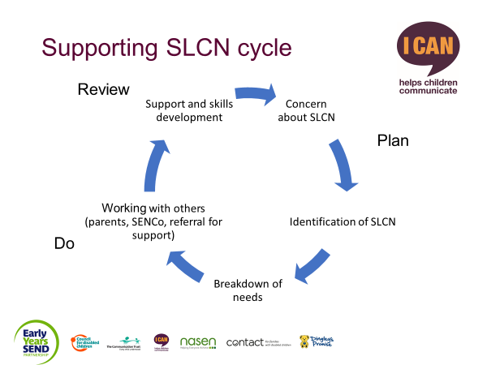

**Identifying SLCN**

|  |
| --- |
| **Activity four: Identifying children with SLCN** |
| **Notes:**   * How would you know if one of the children in your setting had SLCN – what would they ‘look like’? * How could you find out more about their needs? * Do you use any specific tools or checklists? |

**Early Talk checklist**

|  |  |
| --- | --- |
| **Listening and attention** | |
| **Does the child?** | Find it difficult to listen to instructions and/or stories?  Find it difficult to concentrate on anything for more than a few minutes?  Find it hard to listen to instructions while carrying out an activity?  Find it difficult to complete a task?  Become easily distracted from what they are doing?  Appear to ignore adults? |
| **Understanding of language** | |
| **Does the child?** | Appear confused/anxious when spoken to?  Understand only a small number of words?  Find it difficult to follow instructions?  Watch other children to find out what they need to do?  Respond inappropriately to questions and instructions?  Find it difficult to understand a range of concepts such as size, shape, position, colour and quantity?  Find it difficult to respond to ‘wh’ questions such as ‘where’ and ‘who’? |
| **Expressive language and speech** | |
| **Does the child?** | Prefer to use gestures/pointing rather than words?  Find it difficult to talk about past and future events?  Find it difficult to talk about an event the listener was not present at?  Use a limited number of words and simple grammatical structures?  Have very unclear speech?  Struggle to get words out/stammer? |
| **Communication** | |
| **Does the child?** | Find it difficult to play with peers? |
| **Notes:** |  |

**Screening Tools**

**Identifying children’s speech, language and communication needs in your setting**

|  |
| --- |
| **Activity five: Think about what your setting needs.** |
| **Notes:**   * Screening tool / detailed assessment * Who might deliver this? * Which tools are you keen to find out more about? * Who else needs to be involved? |

|  |
| --- |
| **Activity six: Referral to speech and language therapy.** |
| **What is your local process?** |

**Slides:**

1.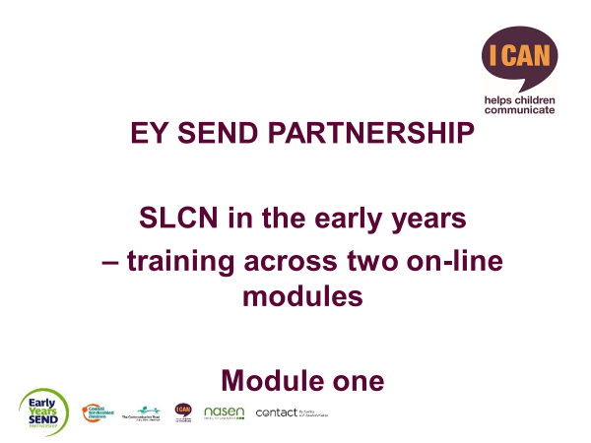 2.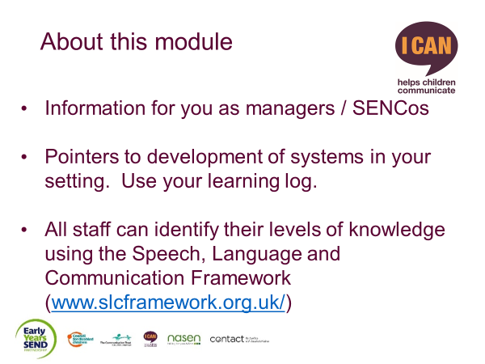

3.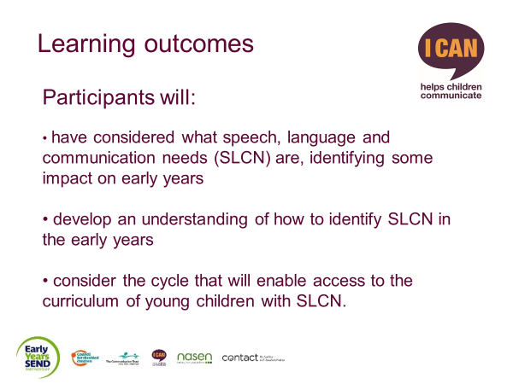 4.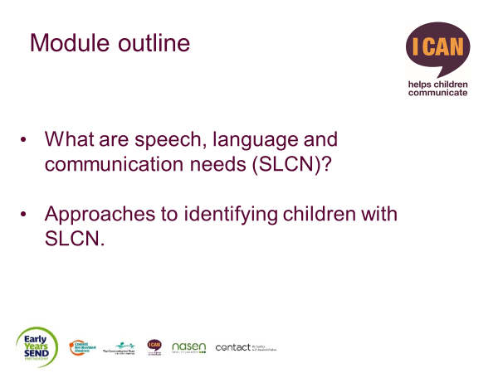

5. 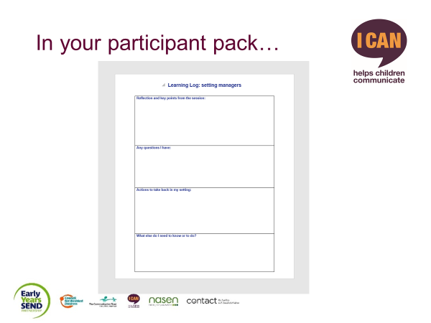 6.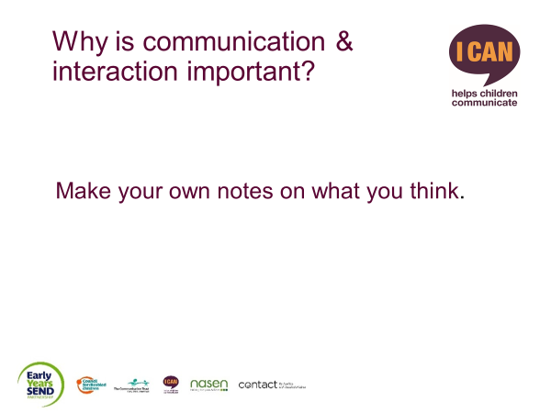

7. 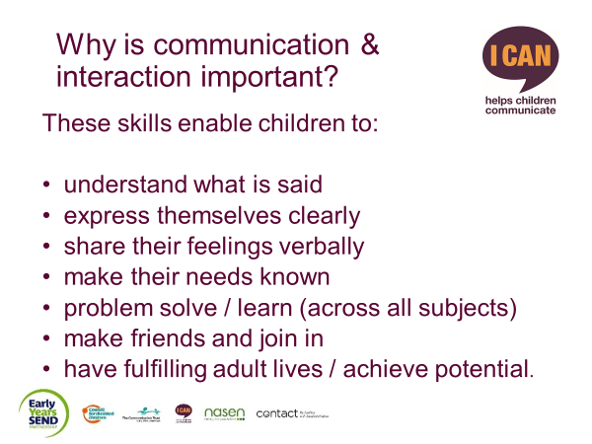 8. 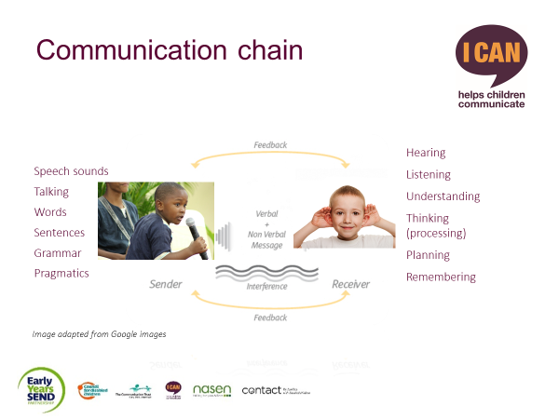

9. 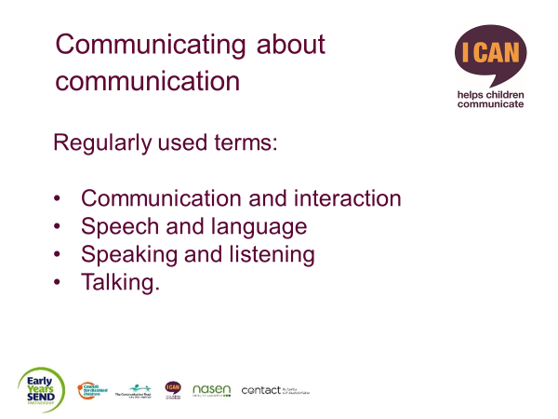 10. 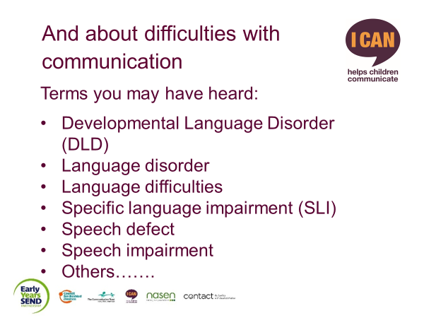

11. 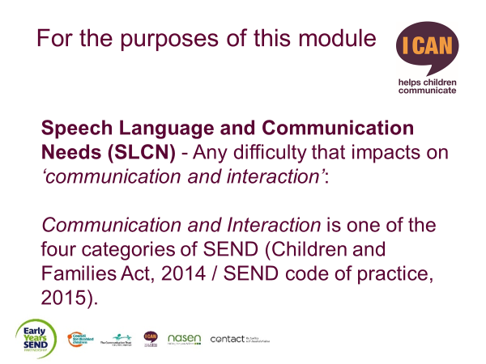 12.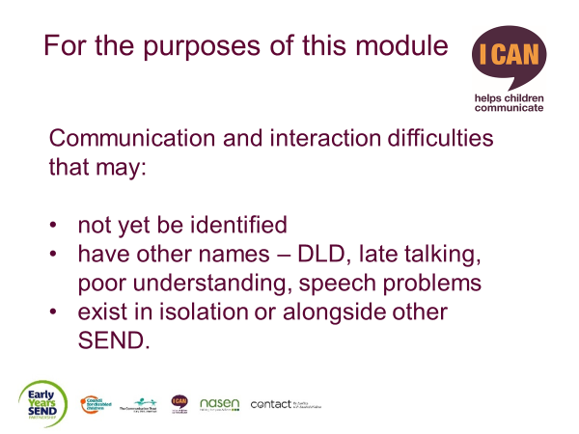

13. 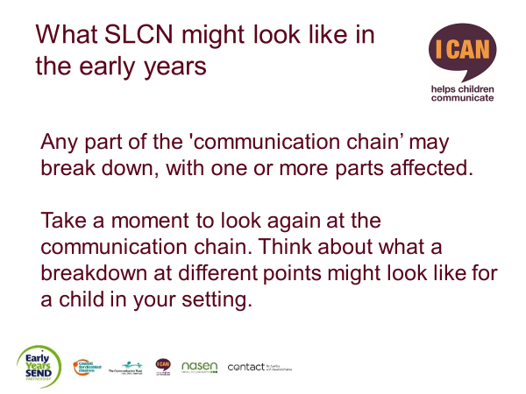 14. 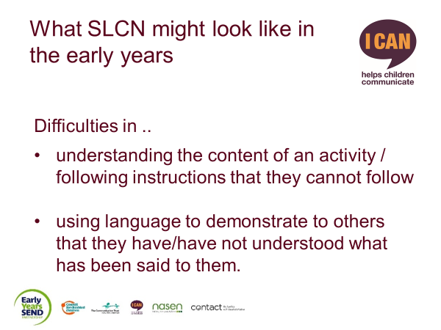

15.  16. 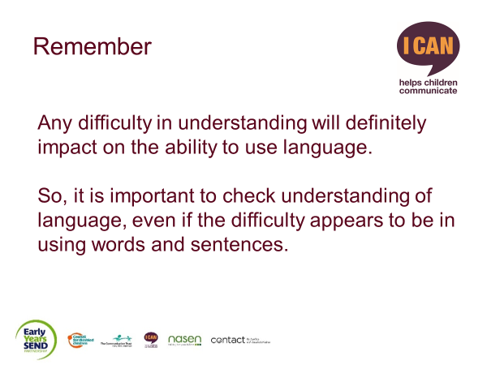

17. 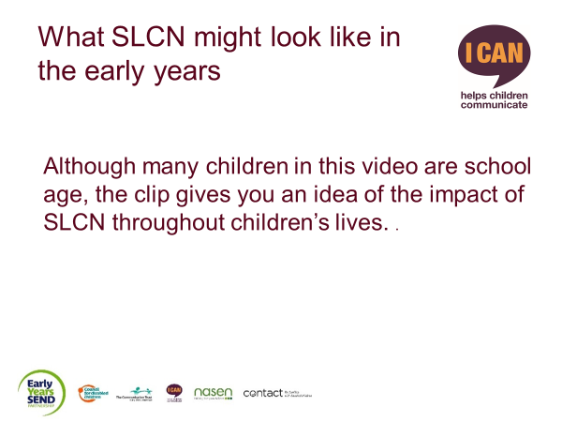 18. 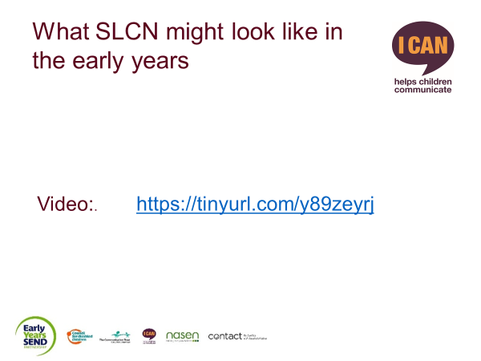

19. 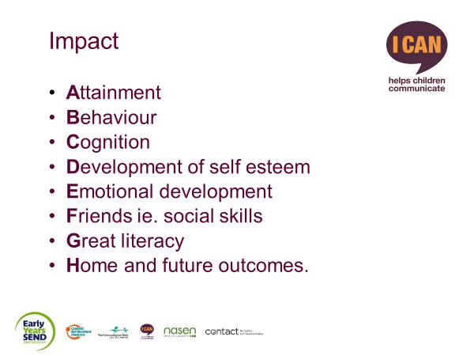20. 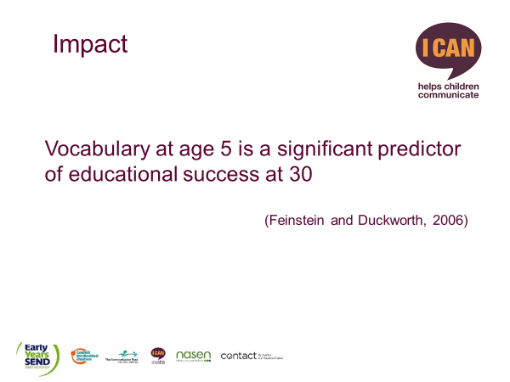

21. 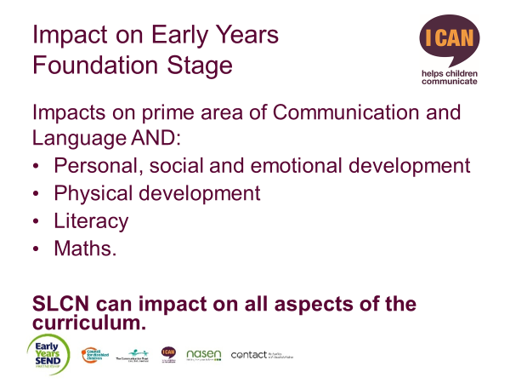 22. 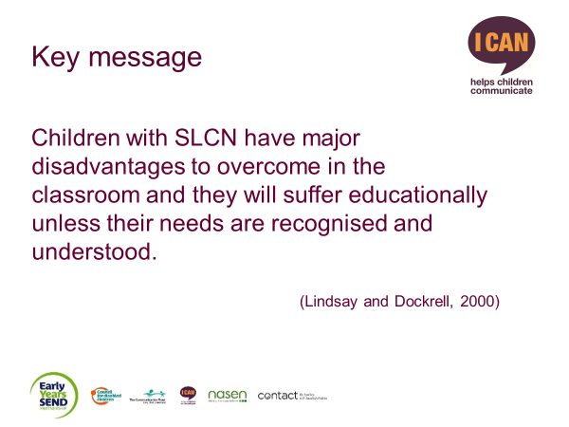

23. 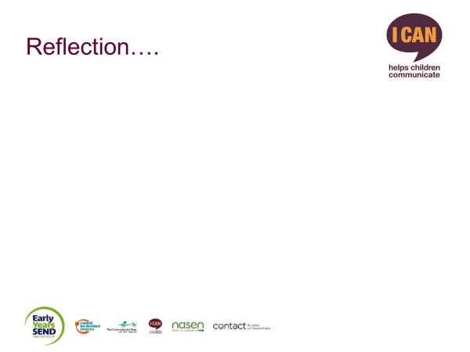 24. 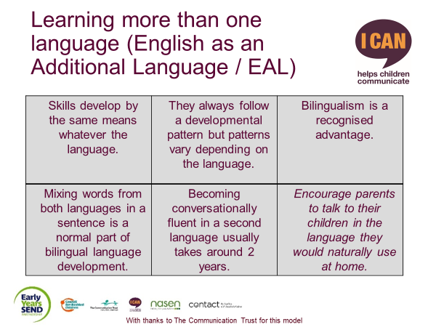

25. 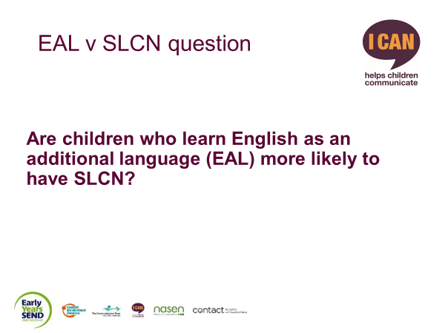 26. 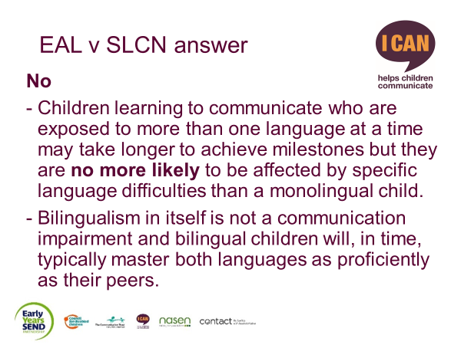

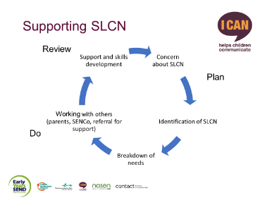

27. 28. 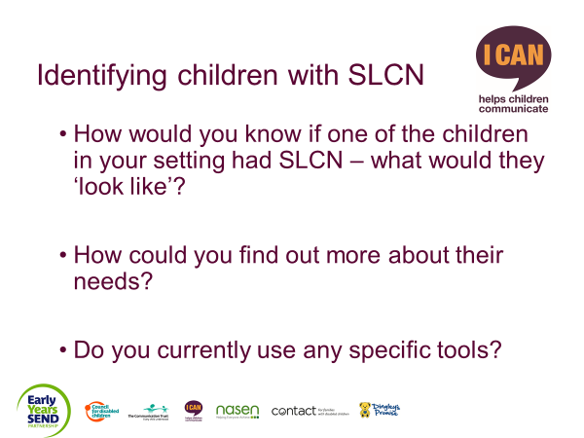

29. 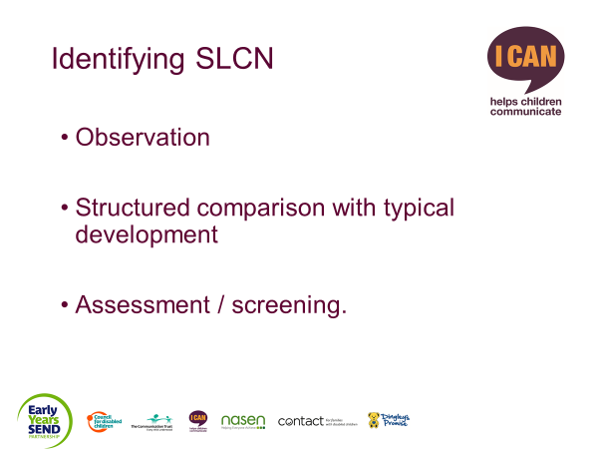30. 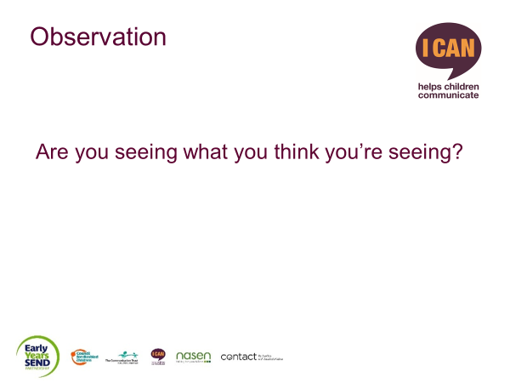

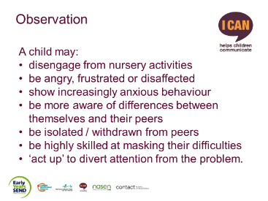31. 32.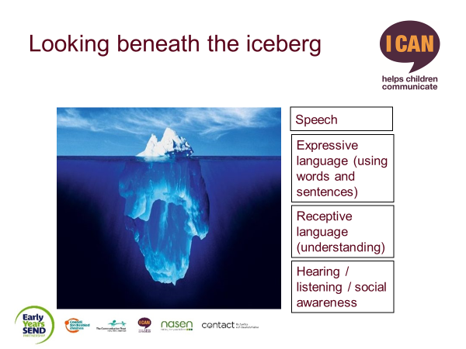

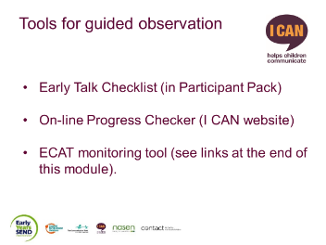33. 34. 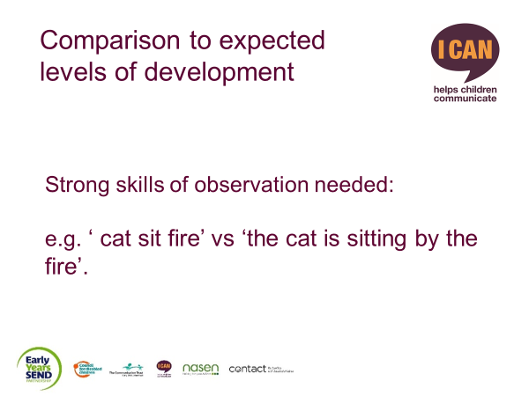

35. 36. 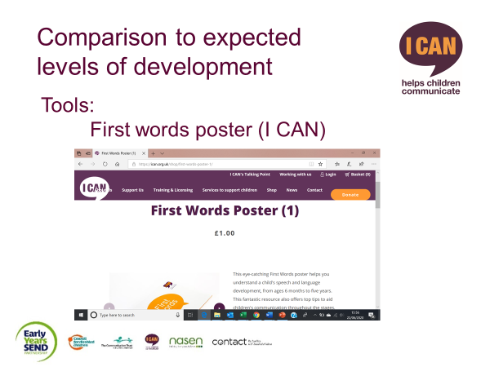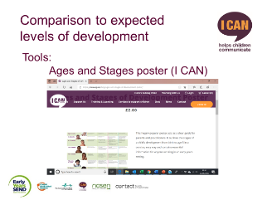

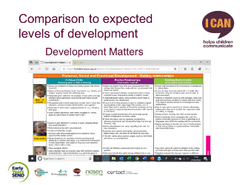 37. 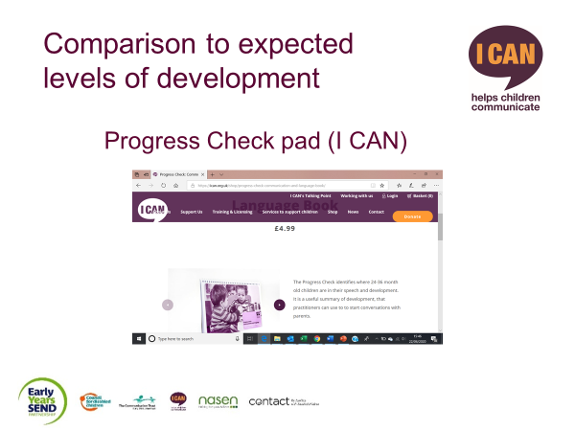  
 38.

39. 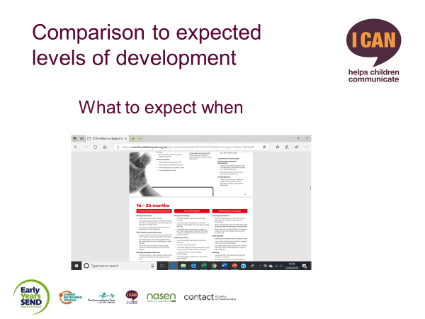 40. 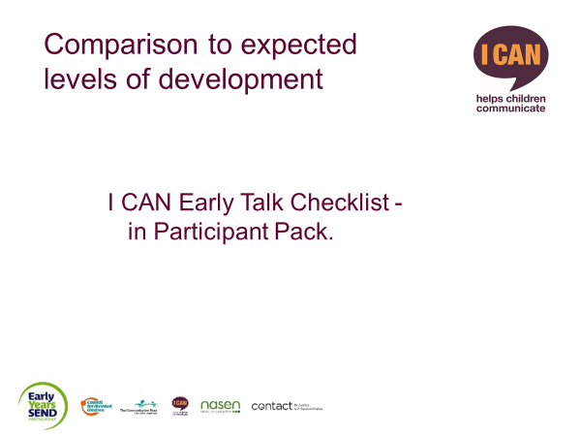

41. 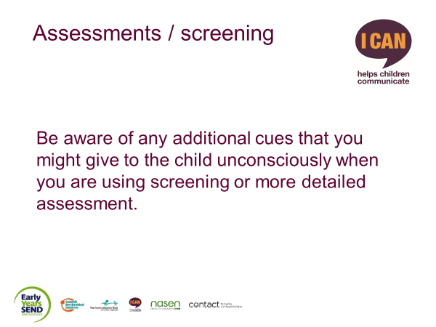 42. 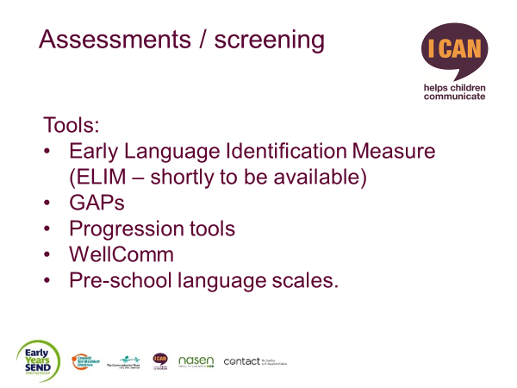

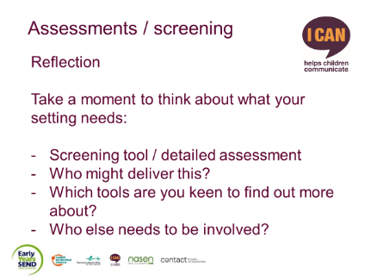 43. 44. 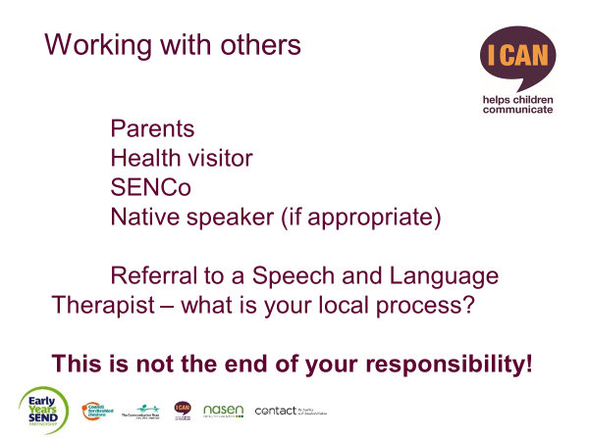

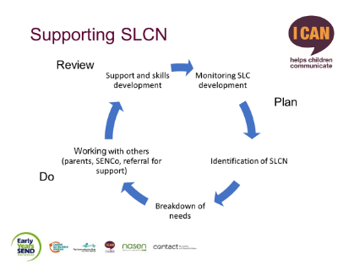

45. 46.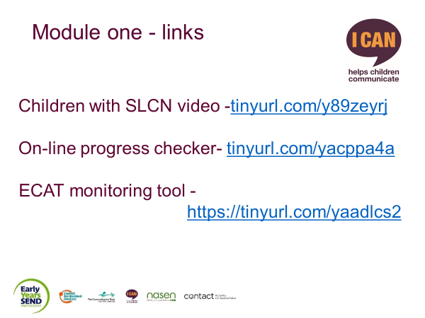

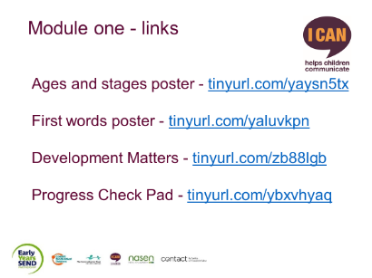

47. 48. 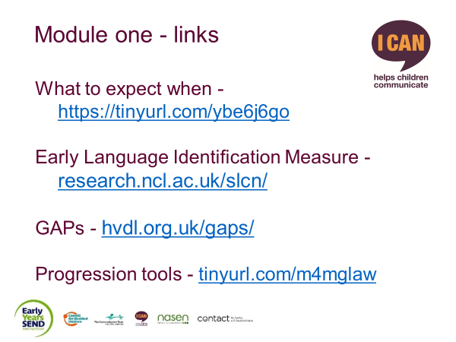

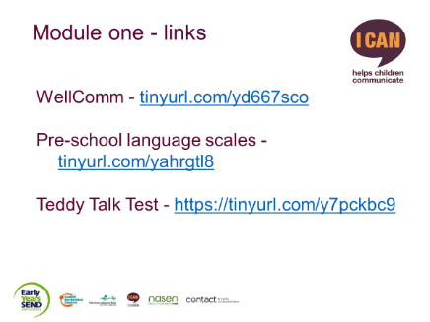

49. 50. 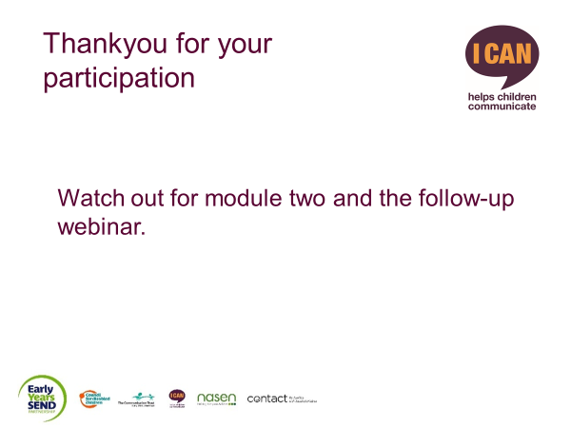

Thankyou for taking part in SLCN in early years settings – module one. Revisit the I CAN website to access module two and to book your place on the coaching webinar.

If you have any queries about this training, please contact eysend@ican.org.uk

|  |  |
| --- | --- |
| **Appendix one: Impact of SLCN** | |
| **What might a child with SLCN ‘look like’ (and how do their difficulties impact their learning)?** | |
| **Type of behaviour** | **How it affects access to the curriculum** |
| Cannot start a task (or slow to start and/or finish). Often rely on other children to take the lead and then follow. | *Takes a long time to complete a task.*  *Unable to work independently.*  *Continually asking for support or passive.* |
| Difficulty in understanding and following instructions; may then be perceived as being ‘naughty’.  May focus only on the first or last thing they heard. | *Not completing activity as directed.*  *Distracted from task and doing ‘own thing’. Needing individual help and support to keep on task.*  *Difficulties in listening and attention.* |
| A tendency to daydream, wander around, seem over active, restless or passive. | *Difficulty in maintaining concentration on activities. May have poor social interaction skills and unable to work in a group.*  *May be disruptive in setting.*  *May not be able to take full advantage of experiences/activities on offer.* |
| Inappropriate responses to verbal questions, comments and instructions. | *Difficulty understanding language and social contexts.*  *Difficulty carrying out tasks, especially working independently.*  *Difficulty in taking part in group work, such as story time, circle time.* |
| Disorganised in their approach to work and play. | *Poor organisational skills may not be able to select what is needed to start an activity.*  *May find changes in the day difficult to cope with.* |
| Appear to ignore the practitioner. | *Not able to understand group instructions.*  *Unable to respond unless prompted individually.*  *Single channel attention.* |
| Inability to demonstrate active listening. May look at teacher while they are speaking but then not be able to recall what has been said. | *Poor listening and attention skills, sometimes hard to detect when the child sits well and appears to be listening.*  *May have difficulties in understanding language. May have difficulty in learning from language-based activities.* |
| Difficulty in taking turns in a game/difficulty in social interaction. | *Poor social skills for sharing equipment in a class and in conversational turn taking.*  *May need adult support in social situations and activities.*  *May have little interest in others around them.* |
| Poor emotional control, e.g. overreacting to events. | *May find it difficult to understand routines and changes in the nursery timetable.*  *May not be able to settle into the group, needs and demands a lot of individual attention.* |
| Cannot maintain a topic of conversation in a group. | *Difficulty understanding and expressing language.*  *Pragmatic difficulties.*  *Difficulty with friendship formation and maintenance.* |
| Cannot share nursery toys with peers. | *Misses out on opportunities to develop social interaction skills.*  *Could disrupt the group and could become isolated and miss opportunities to learn to work cooperatively with peers.* |
| Speech sounds unintelligible, e.g. ‘Dis rubile looks like biscetti’. | *Difficulty interacting with peers and adults as may be misunderstood. Could lead to behaviour difficulty, e.g. becoming disruptive or too quiet.*  *Could have impact on literacy.* |
| Difficulty with separating from parent/carer, e.g.  becoming upset. | *May lead to parent becoming anxious and may affect parents’ relationship with early care provision. May need high level of support and not settle into a routine.* |