Lion’s Den initial application form (please refer to guide before completing)

Name of your group: Registered charity number if applicable

Project name (if applicable): Do you have audited accounts?
Project address:

Contact Name: Telephone:
Email address:
Who will benefit from your project (tick all that apply)

Older people Children and young people Women

People with: physical disabilities learning disabilities mental health issues

Unemployed Single parents Men ex-offenders

Homeless Ex-services Other (please state)
Please give a brief description of your project idea (max. 250 words)

How many people do you think your project will reach?

Is your project a one-off/time limited something you hope will become sustainable

Is your group happy for a member of Bedworth Lions to come out and visit?
Do you understand that if you get through to the next stage of Lion’s Den someone representing your group will be expected to give a short presentation to the Lion’s Den and and invited audience.

How many people do you think would be involved in the presentation?
Do you understand that £5000 is the maximum amount the Lions have to award on the night and this may be divided across a number of projects.

Signed: Date: Pleased print name:
Please return this form by 5pm on 30th June 2018. Following instructions in the guide.
Please note that if you do not proceed to stage two of Lion’s Den then your data will be held securely until we have notified you of the results of stage one.
If you are successful in being invited to stage two then we will securely hold your data until your funded project has been completed and you have returned your evaluation forms.
Lion’s Den application guide
Bedworth Lion’s have a £5000 pot that they wish to make available to projects or organisations that will benefit the people of Bedworth.
The Lions will have the final say in how the £5000 is distributed on the Lion’s Den Evening, Friday 19th October, 2018. If there is one outstanding project then we may award the total to that project, however, we would prefer to be able to distribute the funds across a number of projects- thus benefitting more local people.
This funding is not to be used for: The benefit of individuals (if you are working with someone who has a need please talk to us, as there are other sources of funding available.) To cover ongoing expenses such as utility bills, building costs or salaries/wages. (It may be used to cover sessional worker costs and staff expenses).
We are looking for projects that are innovative or creative; that will benefit a number of individuals and that are not something that the local authority/health service should be funding. We would prefer not to fund an existing project, but please talk to us.
If we think your idea is worth putting forward to the 2nd stage we will contact you about making a short visit to your group to gain a better understanding of the work you do. This will only be one or two Lions. We will also want to discuss safeguarding issues and health and safety implications for your project idea.
We would like to see applications that are creative or innovative, so please use your word limit to make an impression on our judges. If you are successful in getting through to the Lion’s Den event you will be asked to give a short presentation to the Lions & a small audience. It would be to your advantage to make this both informative and entertaining. The Lion’s judges will then have 5 minutes to ask you any questions; please think about financial matters, likely numbers of people you will work with and what you hope to achieve. We hope to make this a celebration of the work done locally, so we hope that groups will bring along their own supporters. We are planning to provide some activities for children on the evening, and a BBC Radio 4 presenter will be hosting the event.
We do not mind if your project idea is for a one-off event, an example would be a social event for lonely people, a time limited project, for example a series of community training seasons; or to puchase equipment for a more sustainable piece of work, for example garden tools and plants to make a community garden.
We would also like to see ideas that bring together different groups, for example something that is inter-generational. However, we do acknowledge that the funding is not massive and therefore we expect groups to have a realistic view of what can be achieved.
We will be asking the local media to cover the Lion’s Den event and so would ask all groups participating to be aware of this.
We expect any groups applying to have a bank account that requires two or more signatures. If you are successful we would require you to complete a short project evaluation form including how you have spent the funds, and be prepared to provide copies of receipts if asked. At Bedworth Lions, we always like to hear from groups we support, so will ask you to come along to a meeting to give us some verbal feedback. This helps us build closer relations with local groups, and helps us plan future funding opportunities.
The deadline date for the initial application is 5pm on Saturday 30th June, 2018. Any applications received after this date will not be considered.
Please complete this application and send it to :
bedworthlionsclub@gmail.com
If you have been successful in your initial application we will be in contact by Friday 20th July.
The Lion’s Den Event will take place on Friday 19th October 2018, 7.30pm At Bedworth Ex-Servicemen’s Club, Rye Piece, Bedworth.
We would like to make this a social event, bringing local people together so would like groups taking part to bring along some supporters. Each group will have 5 complimentary tickets, additional tickets can be purchased from Bedworth Lions or the Ex-servicement’s club, £1 adults, children are free.
The Lion’s judging panel will consist of 3 Lions. The audience will also be given an opportunity to express their support for their favourite idea.
The presentation will be a maximum of 5 minutes, and you can use any means to make an impact, however, because of the size of the room we do not think that powerpoint etc. presentations will work. Each project will then be expected to answer the panels questions or clarify points. This project is based on the popular TV series “The Dragon’s Den” so that should give you an idea of what the evening will be like. If you get to this stage we will be available to answer any questions about the event.
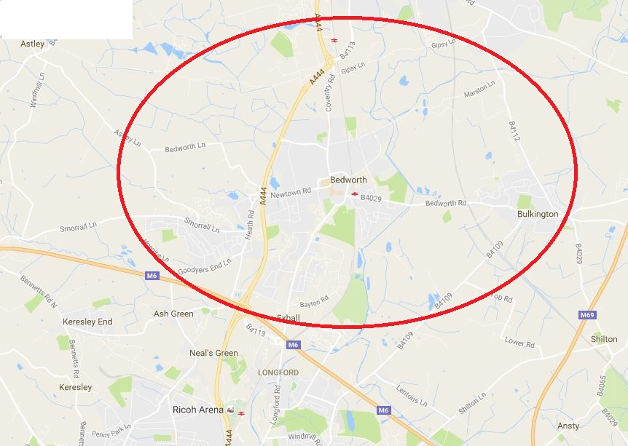
Thank you for taking an interest in the Lion’s Den.

