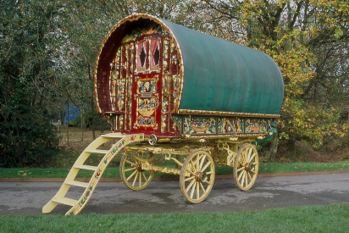
Gypsy, Roma, and Traveller History Month (#GRTHM) 2023
June 1 - June 30
Dear Warwickshire Primary School,
Every June since 2008, people from across the UK have celebrated Gypsy, Roma, and Traveller History Month. Through celebration, education and raising awareness, Gypsy, Roma, and Traveller History Month helps to tackle prejudice, challenge myths and to amplify the voices of Gypsies, Roma and Travellers in wider society.
We are a partnership group made up of numerous practitioners, services, and community representatives, who work within Warwickshire. Our partners include representation from the Office of the Police and Crime Commissioner, Warwickshire County Council, EMTAS, Community Safety, Local Authority, Equip, and a variety of other established service providers.
We are delighted to offer you this exciting opportunity to really get involved in this year’s GRTHM by joining our project for ALL primary schools across the county.
The theme for this year’s GRTHM is “Weaving Journeys”
Patterns of movement captured by artwork can include things such as the migration of GRT communities through time or movement around the county, explore the places Britain’s nomadic communities have been in the past and present, and where new paths could lead in the future.
We are asking your school to join in this year by creating some pieces of art relating to the theme. This could be paintings, drawings, photographs, other pictures, and other pieces of art. The other pieces of art could include patterns representing traditional clothing or artefacts. Let your children express themselves whilst learning about our communities, and how tolerance, understanding, and kindness are so important.
On completion of the artwork, in addition to displaying in school, selected pieces will be displayed across the County in prominent places including Warwickshire Police Headquarters. There will be an opportunity for representatives from participating schools to attend an event at the Warwickshire Police Head Quarters in June to help us celebrate this notable month.
For more details and to register your participation, please contact the Warwickshire Police Gypsy and Traveller Liaison/Advisor, Martin Rone-Clarke or Mandy Waight Ethnic Minority and Traveller Achievement Service
Email: Martin.rone-clarke1@warwickshire.police.uk mandywaight@warwickshire.gov.uk
Tel: Martin 07768 537483 Mandy 07747 475076
Thank you.
Some Questions to Consider
Does your Warwickshire school learning environment respect and value every child’s family and home background, their cultures and communities and the important events in their lives?
Are resources and displays full of positive images that acknowledge and celebrate diversity?
Do the children have opportunities to share different artefacts, foods, music, and clothes, and talk about each other’s practices, habits, and rituals?

