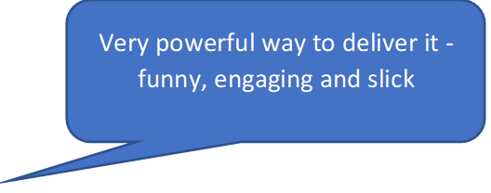

It was superb. I have been teaching for 20+ years and haven't had the need to be trauma informed better illustrated.

Great - using the professional acting company was excellent - really got to the issues we are all facing.

Good to end with the understanding about the brain and body.

**On Friday 29 April 2022 the Virtual School were delighted to lead a session to focus on the extended Virtual School duties:**

**Understanding Children in the Social Care System**



**Why**

Following the extension to the role of the Virtual School, Warwickshire Virtual School invited DTs and DSLs to engage in joint professional development. Working together they can raise awareness of the experiences of children who are or have been involved in the Social Care system. They can develop knowledge and understanding to support colleagues to facilitate better educational outcomes for our most vulnerable children and young people.

**What**

* Being curious about behaviours
* Responding to primary and secondary behaviours
* Supporting staff and understanding their responses
* Developing leadership skills

**How**

An interactive and inspiring event hosted by Geese Theatre Company with Dr Dawn Bradley as keynote speaker. Audience participation is by facilitated group discussion, enabling everyone to contribute.

**Response**

Feedback is extremely positive. Over 80 people attended from nursery, primary, secondary, college and special school settings. Feedback shows reflection on personal learning and impact for the settings.

**Due to the excellent feedback we are planning to run this training again next year, please look out for the date in DT communication / Heads Up.**

Excellent

Very powerful representation through drama of key issues, which was further backed up by talk during the afternoon.

I want ALL my staff to experience it. We have an increasing number of children witnessing DA and I wouldn't say that we are somewhat desensitised but that performance really made you see it through the eyes of the child.

Absolutely amazing, such a powerful platform for such an emotive subject!

The best session that I have ever attended . Very informative , engaging and interesting.

I would love all staff to experience this training to consolidate their learning around AATI and relational approaches

Exceptional! Getting delegates’ creative brains engaged then drawing out the theory was a truly brilliant way of enhancing learning. The interactivity was very powerful.

Very powerful way to deliver it - funny, engaging and slick

Amazing training, loved the interaction

Really makes you reflect , think about how professionals deal with incidents , and thinking of the bigger picture.