**Facing hardship**

Information to share with residents to signpost to support available from Warwickshire County Council and partners.

**WCC links**

* General information and support - [www.warwickshire.gov.uk/facinghardship](http://www.warwickshire.gov.uk/facinghardship)
* Food – [www.warwickshire.gov.uk/foodsupport](http://www.warwickshire.gov.uk/foodsupport)
* Crisis support from Local Welfare Scheme – [www.warwickshire.gov.uk/localwelfarescheme](http://www.warwickshire.gov.uk/localwelfarescheme)
* Winter wellness – [www.warwickshire.gov.uk/winterwellness](http://www.warwickshire.gov.uk/winterwellness)

**Contents**

* Flyers – 1. general support 2. Fuel vouchers (docs in attached file)
* News

**Flyers**

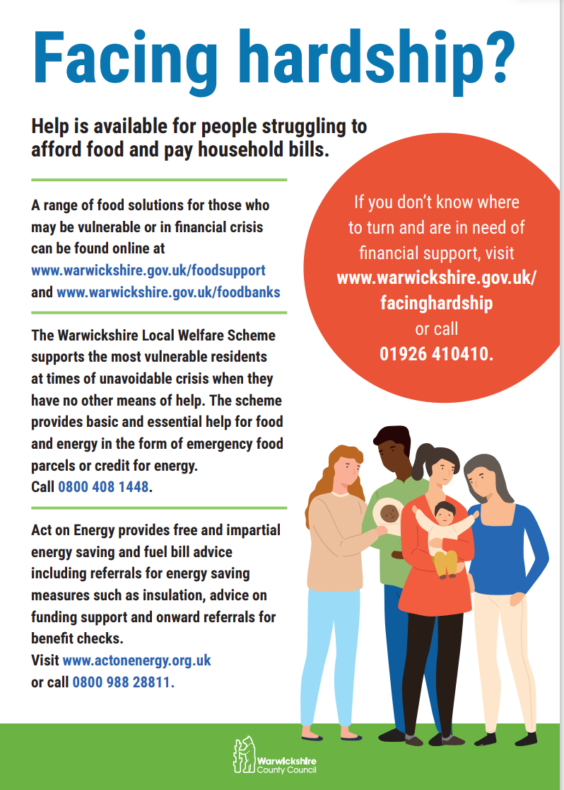

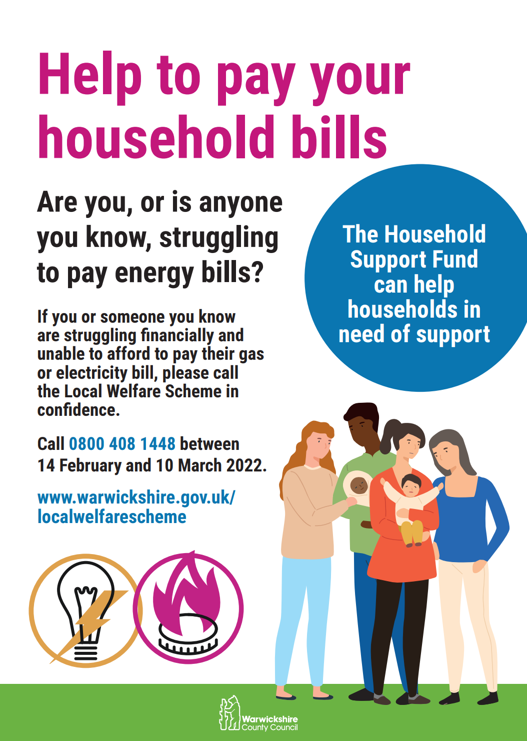

**News**

**Newsletter article**

**Help for people struggling to manage their finances**

Many people are coming to terms with the financial consequences of the pandemic and news of rising household costs will leave many residents feeling concerned about how they will make ends meet.

Support is available for Warwickshire families and individuals facing hardship who may be worried at this time.

Warwickshire County Council’s Local Welfare Scheme helps the county’s most vulnerable residents at times of unavoidable crisis when they have no other means of help and can provide financial support and advice for people who need support to access food and to meet household costs.

The scheme also signposts to further support available from other public, community and voluntary services around the county. This includes debt and money management advice, family information and support, help to access food and household essentials and putting people in touch with local emotional health and wellbeing services.

People are encouraged to look online and get in touch, either for themselves or on behalf of someone else, to find out what help there is.

Contact the Warwickshire Local Welfare Scheme on 01926 359182 or 0800 408 1448 or visit [www.warwickshire.gov.uk/localwelfarescheme](http://www.warwickshire.gov.uk/localwelfarescheme)

For information about wider support from the council and other services, go to:

[www.warwickshire.gov.uk/facinghardship](http://www.warwickshire.gov.uk/facinghardship)

Anyone who wants to help others who in their community who may be struggling can consider donating food, clothing and other household items. Many supermarkets have food collection points and local charity shops will advise what sort of donations are needed.

**Media release - Household Support Fund for fuel - 14 Feb 2022**

**Help for Warwickshire residents struggling with utility bills**

Warwickshire County Council is once again supporting residents who need help to pay their utility bills.

The council’s Local Welfare Scheme is offering a one-off payment to families and households finding it difficult to pay for fuel. This is the second round of fuel support from the council following a promotion in November 2021 where over 10,000 vouchers were issued to people in need.

The support is being funded by the Department for Work and Pensions’ Household Support Fund, which supplements ongoing emergency support from the Local Welfare Scheme for residents in financial crisis.

Sudden unexpected costs can create real challenges for Warwickshire residents who are experiencing financial hardship. The Household Support Fund is available to provide short-term financial support to meet immediate needs and help those who are struggling to afford to pay for energy.

Families and households in Warwickshire can apply whether they use pre-payment meters, pay by direct debit or on receipt of an energy bill and applications for the payment, in the form of a voucher, must be made by 10 March 2022. Residents are invited to contact the Local Welfare Scheme team for a confidential discussion about their situation.

Warwickshire County Councillor, Heather Timms Portfolio Holder for Environment, Climate and Culture, said: “This is a time of increased strain for many people and the financial consequences of the pandemic and news of rising household energy bills will leave many residents feeling worried about how they will make ends meet.

“The council is on hand to provide help and as part of our wider offer we are pleased to again offer vouchers towards fuel bills to low-income families and those who can demonstrate need. Over 10,000 fuel vouchers were issued last time and February's allocation, coinciding with half term, will extend this offer to many again.

“I’d like to remind people in crisis to contact the Local Welfare Scheme which offers support to those with no other means of help either directly, or through extensive links with a range of support services in the county. I strongly encourage people to look online and get in touch, either for themselves or on behalf of someone else, to find out what help there is.”

A resident who received support last December told the council how the Household Support Fund had helped them: “I just wanted to say thank you. 2020 and 2021 have been tough. Throughout the year I have struggled and the vouchers you have sent have been a blessing. It means a lot, truly. Thank you, and the words don't quite say it enough.”

Anyone entitled to benefits eligible free school meals will automatically receive this support and applications are welcome from others in financial difficulty.

To apply please call 0800 408 1448 or 01926 359182 to speak to an advisor in confidence. More information about the Local Welfare Scheme is online at [www.warwickshire.gov.uk/localwelfarescheme](http://www.warwickshire.gov.uk/localwelfarescheme). For more information about financial support go to [www.warwickshire.gov.uk/facinghardship](http://www.warwickshire.gov.uk/facinghardship).

ENDS

**Notes:**

What is the Household Support Fund?

The objective of the Household Support Fund grant is to support those most in need of financial support this winter with food, energy and water bills, as the country continues its recovery from the pandemic.

The grant runs from 06 October 2021 to 31 March 2022 and Warwickshire has been allocated £3.47million, which is being distributed through the existing Local Welfare Scheme.