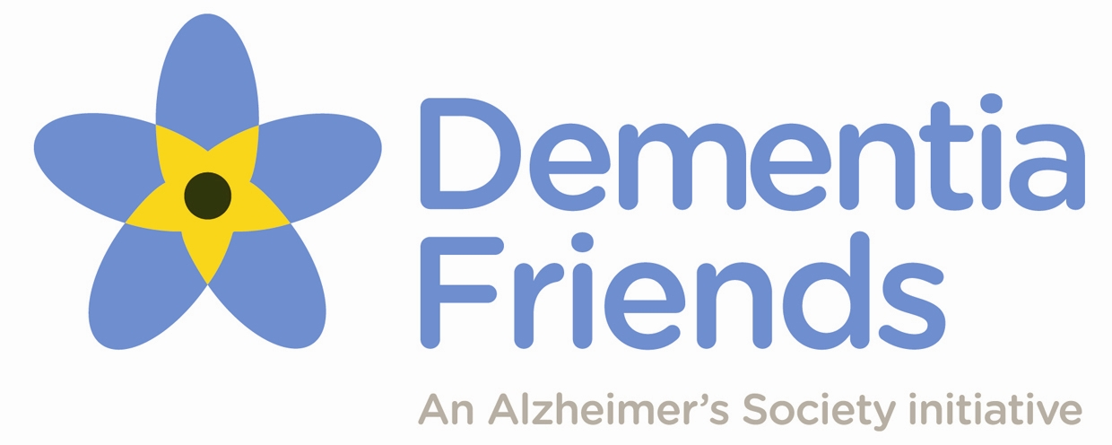
Dementia Friends
Information Session Request
Thank you for contacting us to request a Dementia Friends Information Session. Before continuing, it is important that you and your group understand a little more about what the Information Session will entail:
What is Dementia Friends?
Dementia Friends aims to give people a better understanding of dementia and the small things we can all do to make a difference to the lives of people affected by dementia. Dementia Friends is led by the Alzheimer’s Society and is one strand of its work to create Dementia Friendly Communities. By attending a Dementia Friends Information Session, you have the opportunity to join this national social action movement to change the way people think, speak and act about dementia.
What is an Information Session?
A Dementia Friends Information Session is a fun, interactive way to learn a little about dementia and how it can affect people’s lives. Led by a volunteer Dementia Friends Champion, the Session lasts 45-60 minutes and covers five key messages that everyone should know about dementia, through activities and discussion. At the end of the Information Session, participants have the opportunity to turn their understanding into action by committing to a dementia-friendly action. No action is too big or small – from wearing a Dementia Friends badge to spreading the word on social media.
NB: The Dementia Friends Information Session is not training; volunteer Champions are not dementia experts, will not be able to provide further information or advice and are not DBS-checked.
What will happen next?
After making your request, you will be matched with a volunteer Champion who will contact you to finalise the Information Session details. You will need to keep in touch with this volunteer and confirm any changes to the details below with them.
You will also need to ensure your full group is ready at the agreed start time and that the Champion is given the full duration to run their session (45-60 minutes).
You will also need to provide a safe venue for the Information Session and should ensure it has public liability insurance. Champions will not be able to deliver an Information Session in a venue without this.
Please be aware:
- Dementia Friends cannot guarantee that a Dementia Friends Champion will be available to deliver the Information Session. If we are unable to provide a volunteer Champion for the requested date, we may ask you to provide alternative dates for the Session.
- Dementia Friends and/or Champions retain the right to cancel or end the Information Session at any time.
- Any compliments, complaints or feedback should be provided to dementiafriends@alzheimers.org.uk, not the volunteer Champion.
Dementia Friends
Information Session Request
Your details
Name
Organisation
Job Title
Telephone Number
Email Address

Venue details
Venue address (Including postcode)
Does the venue have… (tick all that apply)
 | Public liability insurance? _{(mandatory)} |  |  | Wheelchair access? |  |  | Hearing loop available?
Will someone be available on the day to explain the fire evacuation and general housekeeping procedures to the Dementia Friends Champion?
If so, please provide name and contact details opposite.
If not, please use the space opposite or attach a document to provide this information.

Is there anything else the Dementia Friends team should be aware of?
E.g., the audience includes young people or children, you wish to take photographs
Information Session details
This session is… (tick one)
A private session for my group.
Open to members of the public, as well as my group.

NB. Please complete one row per session requested. Dates should be at least 3 weeks away. If flexible, please insert multiple dates. If requesting more than three sessions, please continue on a separate sheet.
Minimum of 8 people per Session.
Number of sessions you require:

Please fill in the proposed dates and times…
1 | Date |  | Start time |  |  | End time |  | Group size
2 | Date |  | Start time |  |  | End time |  | Group size
3 | Date |  | Start time |  |  | End time |  | Group size
Notes:

Further information
If you would like to receive information on Local services, your Local Dementia Action Alliance, Fundraising or Training with the Society then please tick the boxes below and a member of the Dementia Friends team will be in touch with further information:

 | My local Dementia Action Alliance  Local organisations working together to create a Dementia Friendly Community. |  | Local Alzheimer’s Society services  Services available to people with dementia and their carers, e.g., Singing for the Brain, Memory Cafes.
 | Fundraising for Alzheimer’s Society  Dementia Friends is led by Alzheimer’s Society, who welcomes donations. |  | Training available from Alzheimer’s Society  Alzheimer’s Society offers in-house and public courses to provide further information about dementia.

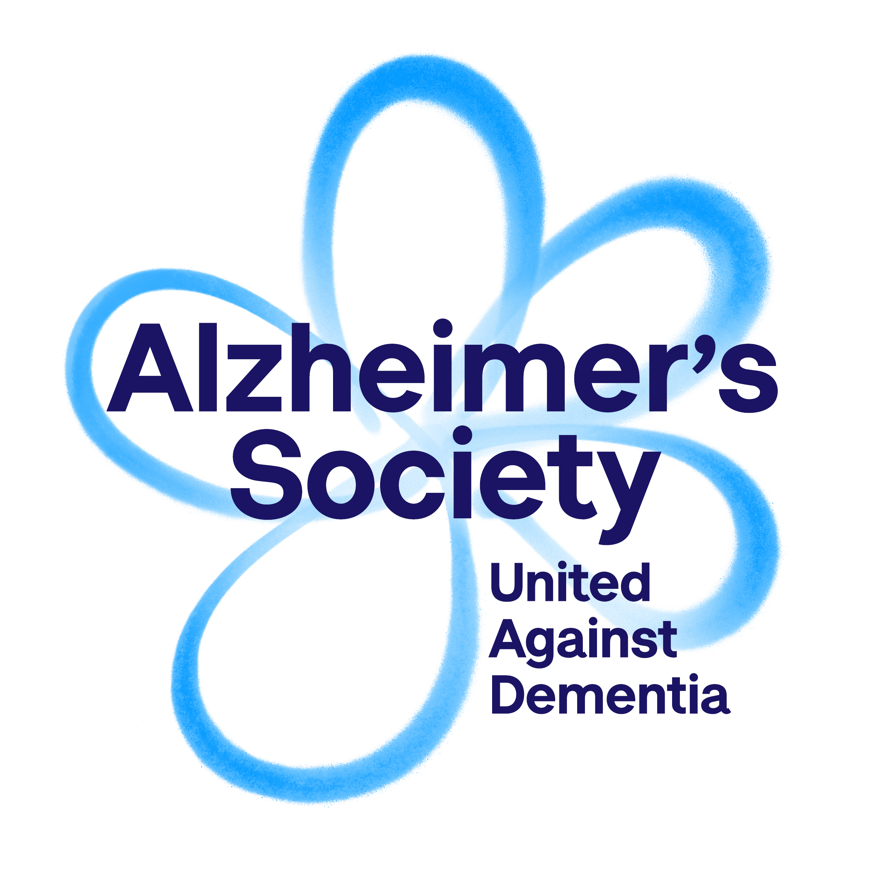
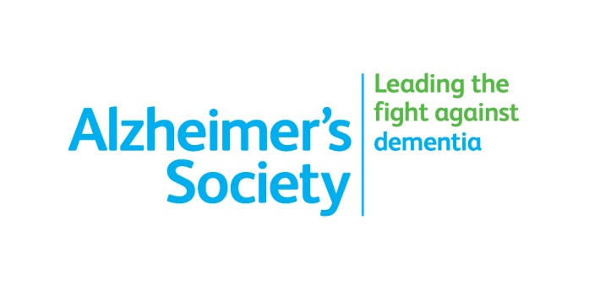
Please return your completed form to me Ian.Hind@alzheimers.org.uk
© Alzheimer’s Society
Dementia Friends is an Alzheimer's Society initiative
© Alzheimer’s Society
DF is an Alzheimer's Society initiative.
Alzheimer's Society is registered as a charity no. 296645

