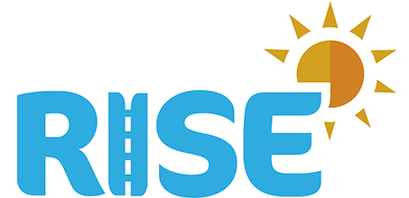
Instagram: @CW_Rise
FB: RISE
Twitter: @CWRISE
Website: www.cwrise.com

BE KIND
18-24th May is Mental Health Awareness Week

DAY 3
Learn a phrase in a new language

“We are all different kinds of people but being kind is the best kind.”
Try to learn this sentence in a different language every day
Here are a few suggestions but you can choose any language you want.
French: Nous sommes tous des gens différents mais étant gentil c'est le meilleur genre
Chinese: 我们都是不同的人，但善良是最好的一种
Wǒmen dōu shì bùtóng de rén, dàn shànliáng shì zuì hǎo de yī zhǒng
Listen to the translation and enjoy the sounds of the words. Try to write and draw the shapes of the letters

