
18-24th May is Mental Health Awareness Week
MENTAL HEALTH IN SCHOOLS TEAM
BE KIND

Banana Loaf
Method
You will need a loaf tin, (17 x 9 x 9cm)
Lightly grease the loaf tin and line it with non-stick baking parchment. Pre-heat the oven to 180°C.
Measure all the ingredients into a mixing bowl and beat for about 2 minutes, until well blended.
Spoon the mixture into the prepared tin and level the surface. Bake for about 1 hour, until well risen and golden brown. A fine skewer inserted in the centre of the cake should come out clean.
Leave the cake to cool in the tin for a few minutes, then turn the cake out onto a wire rack.
Ingredients
100g (4oz) butter, softened
175g (6oz) caster sugar
2 eggs
2 ripe bananas, mashed
225g (8oz) self-raising flour
1 tsp baking powder
2 tbsp milk
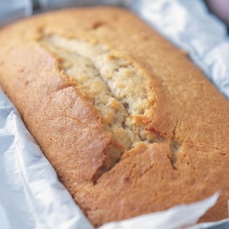
Spending time baking either on your own or with a parent or sibling can be enjoyable and relaxing. As you beat all the ingredients by hand you are engaging in “heavy work” which can help you to self-regulate and feel calmer.
Some other examples of” heavy work” are things like:
- Carrying Heavy Items (eg. sand bag, box of Lego, shopping, chairs)
- Stretching or pulling a piece of Theraband
- Crawling - forwards, backwards, sideways, arm and leg on same side together, and arm and leg on opposite sides together.
- Pushing the wall down – with your hands, shoulders and back
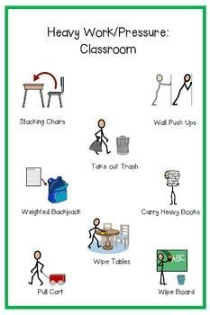

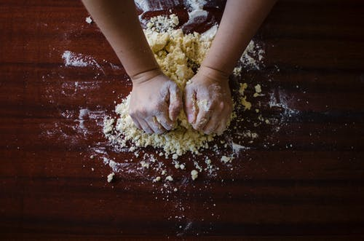
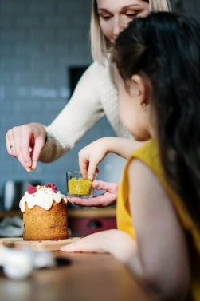
Heavy work to self-regulate
Sharing with others

