|  |
| --- |
| **The Concept-led English Curriculum**  **24 February 2021  9.30 – 10.30 (Online Free to attend)**  ***The domain of English is vast and so we must make brutal choices as to what makes it into the curriculum.*** Join David as he talks us through why English is taught or even, more fundamentally, what it actually is, or should be, as a subject discipline. Is it about developing empathy and being better human beings? Is it about providing pupils with transferable skills like analysis? Or is it about transmitting a culturally enriching knowledge of literature? What is the purpose of a curriculum? |
|  |
| **Building a Reading Culture**  **24 March 2021  1.00 – 2.30 (Online Free to attend)**  ***Changing the culture of a school is a big ask*.** By the time they reach secondary school, many children are aware that reading isn’t cool. According to the National Literacy Trust, less than a third of students read outside of school and about 20% say they feel embarrassed if their friends saw them reading a book. In far too many schools, it’s not considered cool to be clever.  David examines the funny old game that is reading and invites you to consider how reading can be embedded into school life so that all teachers are contributing to students’ reading fluency regardless of subject. |
|  |
| **What do English teachers need to know about cognitive science**  **21 April 2021  9.30– 10.30 (Online Free to attend)**  ***Cognitive Load Theory or the Working Memory Model*** is one of the foundations on which most of cognitive science rests as it makes useful, testable predictions about how we think and learn.  David explores what teachers need to know about the relationship between working memory and long term memory and how it’s perfectly possible for students to solve problems and yet remember nothing about how to solve them again in the future. |

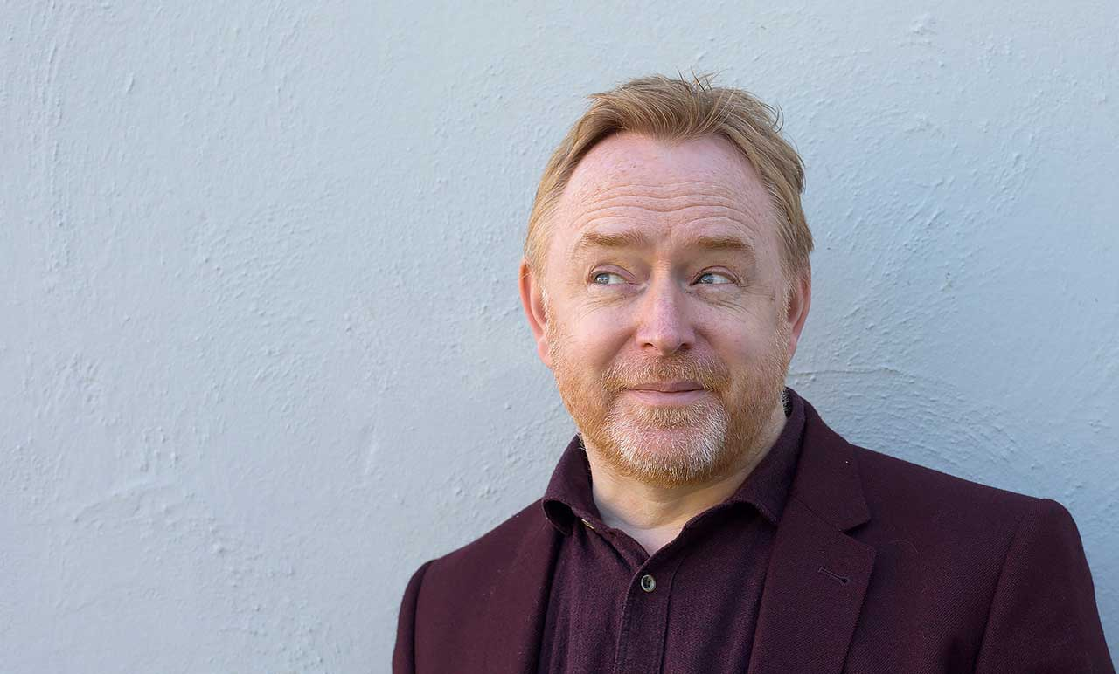

**David Didau: aka The Learning Spy**

**Join us as we explore the world of the English curriculum according to David Didau.**

**Three *FREE* opportunities to spend 90 minutes with David Didau as he questions many of the foundations on which our assumptions about teaching and education were founded**

**with a particular focus on English.**

**Thanks to Warwickshire LA, these sessions have been subsidised,**

**so we are able to offer them free of charge.**

**Places are limited so please email:**

**catts@thepolesworthschool.com to reserve your place**

David Didau’s blog, The Learning Spy, is one of the most influential education blogs in the UK, and he has written a series of books that challenge our assumptions such as, *What If Everything You Knew About Education Was Wrong?*, *What Every Teacher Needs To Know About Psychology* and *Making Kids Cleverer*.