**WARWICKSHIRE FIRE & RESCUE SERVICE BONFIRE COMPETITION 2023**

It’s that time of year again when we look forward to celebrating all the sights and sounds of a fun filled bonfire night. It is important that whilst having fun, safety advice is followed to raise awareness and reduce the risk of incidents.

We would like to invite children to take part in our bonfire competition and will be selecting winners and awarding prizes for entries in each year group.

We are hoping for some fantastic, original stories and poems which highlight how we use all our senses to enjoy the celebrations, but also the important things to remember to keep us safe whilst having fun.

**Closing date: Friday 27th October**

Entries must include name and age of child on the back of the short story or poem.

Please post/email entries to:

Sara Beirne

Community Safety Officer

Bedworth Fire Station

Park Road

Bedworth CV12 8LB

[sarabeirne@warwickshire.gov.uk](mailto:sarabeirne@warwickshire.gov.uk)



**Competition rules:**

Write a short story or a poem about bonfire night **BUT** you must include at least 1 word from each of the following groups –

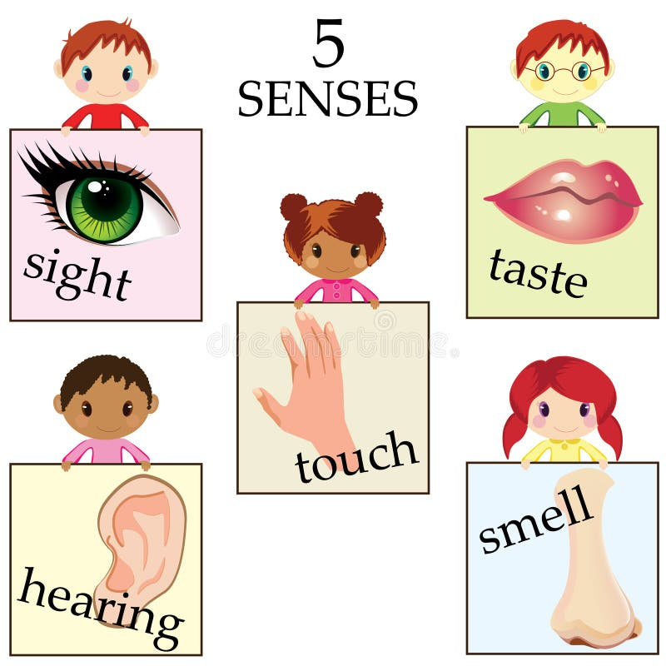

**Smell** **Taste**

Onions Toffee Apples

Smoke Marshmallows

Gunpowder Sausages / Burgers

Hot chocolate

**Hearing Sight**

Whizzing Smiles

Crackling Colourful

Sizzling Glow

Bang Sparkling

Oooooohs /Aaaahs Pretty



**Touch**

Hot

Burn

Gloves

Flames

**Other**

Fireworks Guy Fawkes Sand

Bonfire Safety Bucket

Danger Excited Adult

Sirens Scared Pets

Anti-social behaviour