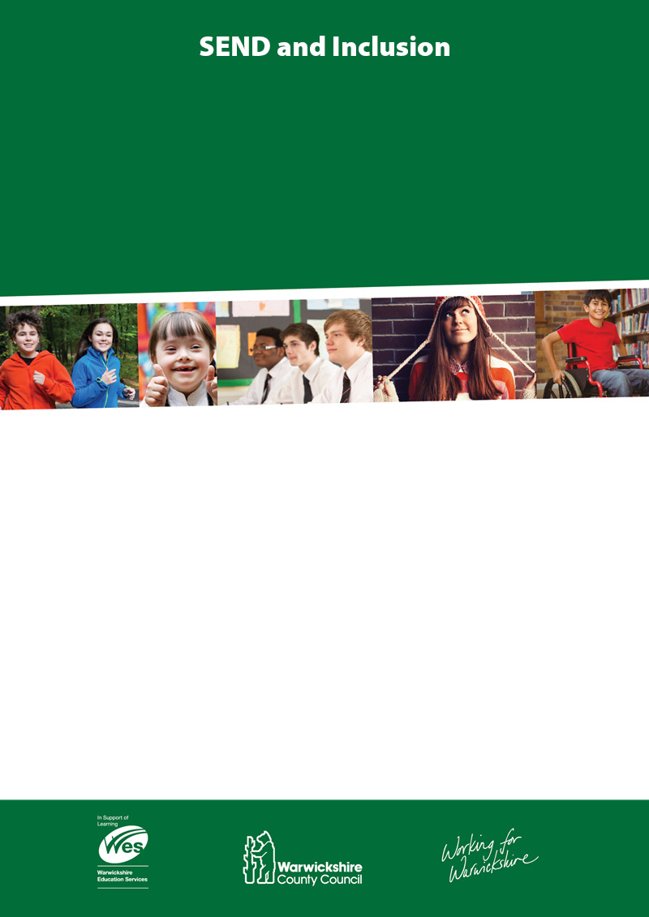

**Objectives:**

At the end of this two hour workshop, everyone will:-

* Have a shared understanding of what makes a SMART Person Centred Outcome for Children and Young People
* Understand the process of writing Person Centred Outcomes for Children and Young People
* Have practised working in multi-agency groups where possible to identify needs and to develop SMART Person Centred Outcomes

**Date of workshop:**

**Session starts at 9:30-11:30am**

|  |  |  |
| --- | --- | --- |
| 9th May 2018 | Pound Lane Learning Centre,  Pound Lane**,** Leamington Spa, Warwickshire, CV32 7RT | Training for Writing Person Centred Outcomes for Children and Young People  (SEN Support and EHCP) |

Cost per module is £25.00 – cancellation at least 3 days in advance non attendance will charged at full price & offered an alternative date

To book a place please press control and click [**here**](https://docs.google.com/forms/d/e/1FAIpQLSe_5YJt29huSnpgeO-bo4Zc4E9WckMwqxWv-VCd62e_QMN8Tw/viewform). If you have any questions please email: [meltwells@warwickshire.gov.uk](mailto:meltwells@warwickshire.gov.uk)

**Training for Writing Person Centred Outcomes for Children and Young People**

**(SEN Support and EHCP)**

9th May 2018

Develop capacity to meet the needs of Pupils on the Autism Spectrum by signing up for…

**Autism Education Trust Training**

We offer a nationally acclaimed, face to face, personalised, multi-tier training programme, supported and quality assured by the Department for Education